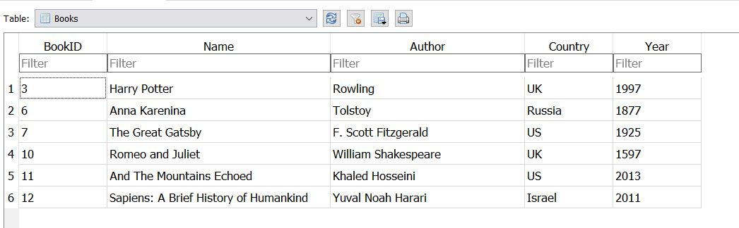

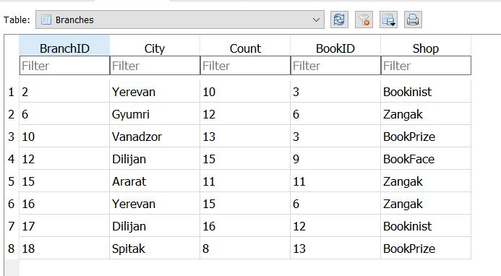

**Add Data to Created Tables**

1. **Count in how many branches exists book with 3 ID**

SELECT COUNT (BranchID)

FROM Branches

WHERE BookID=3

1. **Return the names and cities of all the books from Zangak store**

SELECT Books.Name, Branches.City

FROM Books

INNER JOIN Branches ON Books.BookID = Branches.BookID

WHERE Shop = ‘Zangak’

1. **Count the Sum of books, return sum and name of books 4․**

SELECT SUM (Count) , Name

FROM Books

INNER JOIN Branches ON Books.BookID = Branches.BookID

GROUP BY Books.Name

1. **Return all books name and authors those count between 11 and 15**

SELECT Name , Author

FROM Books

INNER JOIN Branches ON Books.BookID = Branches.BookID.

WHERE Count BETWEEN 11 and 15

1. **Return books names and counts, those are not exists in Yerevan**

SELECT Name , Count

FROM Books

INNER JOIN Branches ON Books.BookID = Branches.BookID.

WHERE NOT City='Yerevan'

1. **Using subquery select the city of the “And the mountains Echoed Book”**

SELECT City

FROM Branches

WHERE BookID = ( SELECT BookID FROM Books WHERE Name = ‘And

the mountains Echoed Book’)